The AI3 CacheBone
Kanchana Kanchanasut (kk@cs.ait.ac.th) *
Suguru Yamaguchi (suguru@is.aist-nara.ac.jp) **
Hiroyuki Inoue (h-inoue@is.aist-nara.ac.jp) **
Panjai Tantatsanawong (panjai@cs.ait.ac.th) *
Kriengsak Kiatsirivatana (b97451@cs.ait.ac.th) *
Apisit Suksakorn (a97368@cs.ait.ac.th) *
* | Computer Science and Information Management Program
 | School of Advanced Technologies
 | Asian Institute of Technology
 | P.O.Box 4, Klongluang 12120, Thailand
** | Graduate School of Information Science,  Nara Institute of Science and Technology, 8916-5 Takayama, Ikoma, Nara, 630-0101, JAPAN.

1. Introduction
The use of World Wide Web (WWW) has been growing exponentially where a new WWW site is being added each minute to the Internet. The explosion of the WWW usage has caused too many requests and thus causing network congestion. To help reduce the WWW traffic over the Internet, caching technology has been proposed and widely adopted.
In order to handle large amount of request, a cache server bounds to suffer from performance problems such as long period of waiting time, consumption of disk storage, etc. Many techniques have been proposed to remedy this situation: prefetching [12], distributed cache systems with replications [19], and hierarchical caching [2]. In the hierarchical caching, several cache servers can be connected each together with hierarchical topology to reduce the number of direct accesses to the WWW servers. Cache servers resolve misses through other cache servers in the higher level of its hierarchy. The hierarchical cache system is implemented widely such as Squid [15] and Harvest [2].
International trials on the cooperative caching (CacheBone) such as NLANR [10] and AI3 [5] projects where number of caches are working together to ensure high hit rates while not having to be concerned about the bandwidth consumption. Within the CacheBone, the inter cache cooperation should be very close to increase the high hit rates and reduce the response time for the end users and to make effective interact bandwidth utilization. This tight interact cooperation has been our primary goal for the AI3 adaptive CacheBone which is described in this paper.
2. Caching World-Wide Web Information
WWW caching is a technique used to improve the performance of WWW by buffering the recently used WWW documents for the next use [16]. The WWW server have to serve all requests of the WWW clients, no matter how many times the same document is requested and possibly these requests are originated from the same place. Popular documents may be accessed over and over again by many people from different time zones for the entire day. They request the same document, connect to the server, and transfer a document over the network. With caching technology these kinds of popular documents can be saved in a cache server within the local network for subsequent use. The network can be relieved from transferring the same document repeatedly. When a document is requested by a client, it is checked to see whether the cache contains a copy of the requested document or not. If so (Cache hit), a copy of document from cache is sent to the client; otherwise (Cache miss) the document is requested from other entities which could be from other peering caches or from the source.
Although, caching mechanism can reduce the global traffic but the page retrieval time plays a very important role in gaining users’ acceptance. In case of a HIT, the retrieval time is greatly reduced but in case of a MISS, the retrieval is expected to be longer than fetching the same information directly from its source. Thus it is very important to maximize the Cache Hit Rate in order to improve the overall performance. Abrams et al. [1] found that no matter how a proxy cache is designed, the maximum value of proxy cache hit rate is 50% which is a serious drawback for cache proxies to gain acceptance. Various techniques have been proposed to increase the hit rates at the expense of increasing the cache size, or sometimes, increasing the intercache traffic.
Cooperating of caching servers forming a CacheBone, is an idea to make use of high speed (or low speed but dedicated) connections among cache servers to ensure higher hit rates at the cost of high bandwidth consumption on the backbone or on the interact links. The cache servers can be linked in a form of sibling and/or hierarchy topologies as illustrated in Figure 1. Sibling caching topology consists of two or more caches in the subnetwork linked together with the high speed link. At the center of this subnetwork is a hub cache which is the parent of all the rim caches within the subnetwork. The hub and the rim caches are interconnected hierarchically such that when a miss occurs at the rim cache, a request is forwarded to the hub cache and its sibling and finally to the original source. Each cache in the hierarchy communicates to the parent or the sibling caches by using Internet Cache Protocol (ICP) [17,18].
Prefetching is a technique used to improve cache hit rate and WWW latency by fetching the documents in advance. For example, a prefetching engine could be looking ahead at WWW objects which are linked to the current page being requested, such as another HTML page, inline images (.GIF, .JPG etc.), sounds (.WAV) and etc. Padmanabhan and Mogul [12] have proposed client base prefetching approach where the client side requires client browser modification to support the prefetch prediction. Prefetching by the server or cache proxy has been proposed by Chinen [3] called Wcol which is a page oriented prefetching. It prefetches linked pages such as HTML, inline images, and etc. This approach was found to improve 20% of the cache hit rate but adds 200% increase of the WWW traffic.
Dias et al [1] proposed a 'smart’ Internet caching system, which employed techniques of neighborhood file referencing. The neighborhood is selected from the highest access frequency which should be the next one accessed from the currently accessed file. This model requires modifications to the transfer protocol between the caches (local gateway and remote gateway), which makes it less practical in practice.
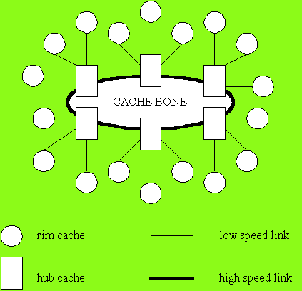  Figure 1 Cache Bone topology. | 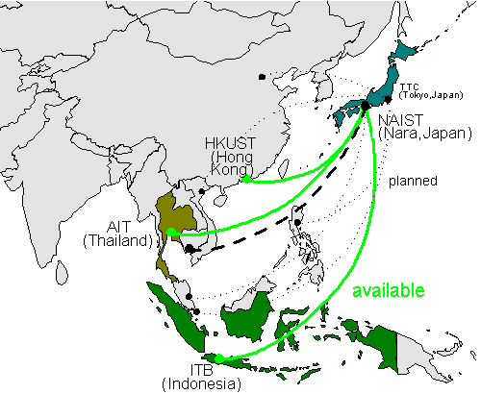  Figure 2 The AI3 Network [3].

3. An Adaptive WWW Cache System
Inoue, Kanchanasut and Yamaguchi [5] proposed an adaptive WWW CacheBone for the AI3 (Asian Internet Initiative Interconnection) satellite network covering several countries, as shown in Figure 2, with Japan as a hub. Within the AI3 cache system, the hub and rim caches cooperate by sharing cached objects and redistribute them to various member caches according to their utilization statistics. Migrations of cache objects take place whenever the communication line is less busy.
3.1 The Hub Cache
The fundamental idea of the adaptive WWW cache system in the AI3 network is a star shaped topology of sibling / hierarchical WWW cache formation. In ordinary satellite Internet, there is a single hub earth station and satellite communication channels are installed from the hub earth station to several rim earth stations as star shaped. Therefore, it is very natural to install a single high-performance large capacity WWW cache server as a hub cache at the location of the hub earth station. The sites of rim earth stations can install its own rim cache to make hierarchical formation of WWW cache servers. In the AI3 network, the hub cache is hooked up to the broad band Internet backbone in Japan, therefore, the prefetching technique [3, 5] can be used for improvement of hit rate as well as reducing users' waiting time. In order to make more improvements on WWW object hit rates, two approaches in distributing web objects from the hub to the rim caches are implemented.
In the first approach, we developed cooperative cache management between rim caches and a hub cache [5] where we implement a protocol which periodically updates the table of cached WWW objects at the hub cache, and then transfer popular WWW objects from the hub to the rim caches thus making replications. The strategy on how we make replications at the rim caches is based on the statistical analysis of page usage at the rim cache.
To share web objects fetched from different rim caches, each time an object is fetched by the hub cache from the Internet, a copy of the object is kept at the hub cache for ease of subsequent accesses by all member rim caches. Our second approach is for the hub cache to push or multicast commonly popular web objects to all rim caches simultaneously. That means normal web documents are delivered by the hierarchical caching system, while the popular web document is delivered by the multicast push caching. A simulation study by Rodriguez et al [13], which concluded that distribution scheme for Web documents on the Internet should be implement with both schemes hierarchical caching and multicasting of hot and frequently changing pages, has given us a strong supporting justification that both schemes on should be supported by our CacheBone.
Multicast transmission could unnecessarily flood the network if not handled with care. An effective mechanism has been designed to control the bandwidth consumption in the multicast transmission which adapts the transmission rates according to the current network condition thus making effective use of the bandwidth. In our proposed scheme, the adaptive multicasting can adjust the amount of bandwidth consumption dynamically such that maximum transfer rate that the network can support is used at any given time by using the Monitor Based Flow Control (MBFC) scheme proposed by Sano et al [14] with slight modifications. MBFC is a sender based control flow for reliable multicasting protocol which assuming that multicasting traffic coexists with other traffic, for example, with TCP traffic. The sender initiates and terminates monitoring action at the receivers by sending signals to start and stop monitoring the status of the receiver reception. All rim caches report their reception results to the sender, which is the hub cache. After the sender collects reception results, it adjusts the transmission rate up or down depending on the network condition detectable from the responses received from the rim caches. Within one monitoring region, a fixed number of packets are sent to the receiver and a response is expected to be sent back to the sender withinh one Round Trip Time (RTT) hence we can transfrom the adjusted transmission rate to the corresponding packet size which is to be used by our multicasting scheme until the next adjustment is required. The multicast scheme adopted by our CacheBone thus adapts the packet sizes according to the
Network condition.
In order to avoid flooding the network, we use administratively scoped IP address to scope the multicast transmissions. Transmission errors get reported by the receivers and a random delay backoff approach is used to recover the errors.
The efficiency of our adaptive mechanism is measured by the ratio of packet retransmissions at the hub cache side. Upon receiving lost packet request message, the hub cache must records it to keep the statistics of packet loss. Our experimental results have shown that with adaptive multicasting improvements on both the transmission time and retransmission rates could be achieved and have a tendency to become more significant with larger files as shown below. The retransmission ratio is computed by comparing between the number of retransmitted bytes to all receiving sites with the total file size while the bandwidth consumption is measured by calculating the average transmission rate in the unit of byte per second.
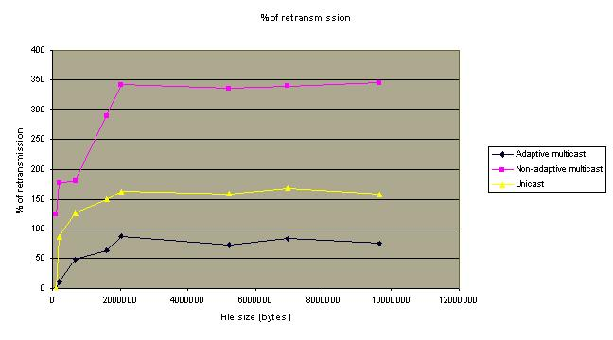
Figure 3 Percentage of retransmission packets
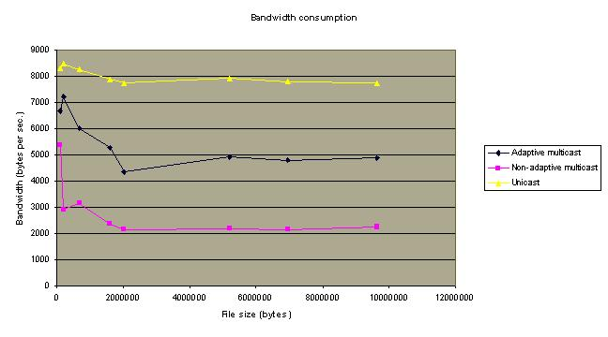
Figure 4 Bandwidth consumption
3.2 Adaptive Rim Cache
The main objective of the proposed scheme is to increase the hit rates by access pattern analysis prefetching and to prefetch whenever the bandwidth is available. The rim cache which is a cache on the end node of the satellite link does prefetching based on access pattern analysis per page and concentrates on optimal utilization of the satellite link between the rim and the hub cache. The rim cache works independently from the hub cache where their interact connection is a T1 satellite link. The main features of the adaptive cache system in AI3 network are as follows:
- Bandwidth control : By observing the traffic consumption and the delay of the satellite link, the cache servers determine whether they should prefetch the WWW objects or not. If the satellite link is congested, the prefetching process of the rim cache will be suspended while the hub continues prefetching, nevertheless. Before the prefetching process is performed, an available bandwidth is measured. If an available bandwidth is lower than the specific threshold (the currently used threshold is 80%), then the prefetching process is suspended. At present, to avoid flooding the network with PING per each decision, we have adopted to use MRTG ((Multi Router Traffic Grapher) [6] service. However, we are planning to upgrade our Squid to version 2 which has SNMP, then a periodic look ups of SNMP objects at the gateways (routers) will be used to determine the current traffic condition.
- Access pattern analysis for prefetching : The rim cache analyzes access patterns and determines which pages are popular, and then prefetches them regularly in order to minimize the overall latency. It builds access pattern statistics that represent the relationships among WWW objects and the frequencies of references or accesses. If a client requests one of the objects, the rim cache determines the priority of related or linked objects, and does prioritized prefetching based on the frequencies of access.
- Prefetching with considering RTT : Prefetching WWW object blindly by the rim cache could result in huge traffic across the satellite link. Therefore, the RTT of the satellite link (500 ms) and the link to the original WWW server are taken into consideration. The rim cache keeps track of the RTT and time for retrieval of each document while it is operating and considers this recorded information in selecting the prefetched WWW object. A WWW object, with retrieval time higher than the RTT, will not be prefetched.
An overview of the system is shown below where there are four independent processes running concurrently
Figure 5 Adaptive cache architecture
The cache manager, which is our modified version of Squid server, receives requests for WWW objects from the users by the HTTP protocol (HyperText Transfer Protocol), in the form of requested URLs, and looks for those objects in the Squid cache. If the requested WWW objects are stored in the cache (cache hit), they are sent to the users immediately. Otherwise (cache miss), the cache manager (which is a normal Squid) requests those WWW objects from hub cache. Every requested URL is recorded to a log file with the following information by the cache manager
- Page information which includes requested URL, file type [such as HTML file or image file (gif, jpg and etc.,)] and file size. The distance metric which is the time consumed in retrieving the requested page from the original site to the cache is also included.
- Frequency of page accesses is a statistics of how often a page is accessed by users over an interval of time. It is increased whenever there is a user request for the page. A page with zero frequency of access over a given interval of time will be removed from the prefetching queue.
- Frequency of update is a cumulative frequency, which is increased when a page gets changed or modified in the original WWW site.
Above information is employed by the process Prefetch in analyzing user access patterns and for future prefetching operations. The prefetching engine operates independently from the cache manager. It keeps sending HTTP requests directly to the Hub cache whenever it knows that there is sufficient bandwidth available for the prefetching operation. An autonomous agent is assigned to take care of traffic monitoring and inform or trigger the prefetching engine whenever the traffic condition is good enough to perform prefetching operations.
URLs are picked from the heap for prefetching in order of their frequencies of access. A heap of URLs prioritized by their frequency of access is used by the prefetching engine to order the prefetching activity. The heap is modified continuously whenever there is a new entry added into the Cache Manager log file, when the root of URL heap is removed for prefetching and when the frequencies of access get updated.
When a URL is picked up from the heap, it is checked against other parameters to determine if it is worth prefecthing or not. The prefetching engine looks up the log file maintained by the Cache Manager every time when it has to make decision to fetch an object. For example, it considers the page retrieval time obtainable from the distance metric in the log file and compares that with the satellite link's RTT to decide whether it is worthwhile to prefetch that particular page or not. If the page is large and it consumes a long time to retrieve, which is reflected by the distance metric, it may not be worthwhile to prefetch in advance even though its frequency of access may be high. This is because we may be risking the fact that the prefetched page may or may not be used at all in the near future. In such a case, it is better to wait until someone requests that particular page and place the page automatically in our cache for subsequent accesses.
One big issue with using copies of documents in place of their original ones is their consistency. In other word, how can we make sure if the version of document received is the most up-to-date one. If the original document is updated, the cached copy will become inconsistent with the original and thus should not be used. Our approach to this issue is to apply the concept of URL-minder [9] which is an expanding service in the Internet. The URL-minder process is an automatic change-detection and notification process, which keeps track of WWW pages list in the cache history. The WWW page changes are monitored by the URL-minder process which sends IMS (If-Modified-Since) message to the original WWW server once a day for each URL, at the moment. To make sure that our cache is consistent, the IMS sending intervals can be adjusted to be in accord with the frequency of updates (higher frequency of update, higher IMS sending frequency). When a stale URL is detected, it will be forwarded to the cache manager to fetch the page and get the most up to date version. In this case, the cache manager, instead of the prefetching engine, prefetches the page for the rim cache. A process which checks if any object within the cache has been updated or not is run once a day. It scans every Web document stored in cache and determines Web document last access time. The stored Web document whose access time is older than the specific threshold (the currently applied interval is within 1 day) must be refetched.
Normally, the process cache manager (Squid) has to check for the consistency of data in the cache before sending it to the requested user. But with URL-Minder feature, our Squid-based cache manager can send the cached object to user immediately without having to check if the requested page has been modified. This is because the URL-Minder has already maintained the consistency of data in rim cache. The user response time is thus improved as compared to normal Squid.
4. Performance of Adaptive Rim Cache
At present, we evaluate the cache performance by collecting run-time statistics over a period of one week Data was collected in one week traces from the Computer Science and Information Management program lab at AIT between 18-26 May 1998. The cache server used was a Pentium processor with 32 MB memory and 600 MB hard disk running FreeBSD version 2.2.1.
The following performance comparisons are made between the adaptive Squid cache and the normal Squid cache:
- The network traffic is measured in the rim network during the experiment using MRTG (Multi Router Traffic Grapher) application [6]. Our cache application was the only application running on our link from AIT to NAIST at that time so MRTG results reflect the actual traffic caused by the intercache communications. Figure 7 illustrates the traffic on AI3 network between AIT and NAIST between 18-26 May 1998. From 18-21 May 1998, the adaptive Squid proxy cache was used while during 22-26 May 1998, the Squid proxy cache was tested with the same workload. The maximum bandwidth consumption while prefetching of the adaptive Squid cache is about 225 Kbps (14.65%), but the normal Squid proxy cache consumes maximum 131 Kbps (8.79%). At peek period, the adaptive Squid cache consumes 5.86% more bandwidth than the normal Squid proxy cache. The average traffic of the adaptive Squid cache is 98 Kbps (6.5%) and the normal Squid cache is 67 Kbps (4.46%), or in other words, the adaptive cache requires only approximately 1.5 times the bandwidth requirement of the normal Squid. The bandwidth consumption distribution of adaptive Squid has a burst characteristic due to the regular prefetching. It utilizes the bandwidth more evenly than the Squid cache though the average bandwidth consumption is higher due to the ongoing prefetching activities. With this even or relatively more predictable traffic utilization pattern, a more effective use of the bandwidth can be planned for or implemented; an overall efficiency improvement should then be achievable.

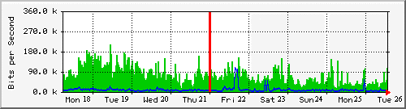

Max In: 225.0 kb/s (14.65%) Average In: 97.6 kb/s (6.4%) Current In: 51.2 kb/s (3.3%)

Max Out: 35.0 kb/s (2.3%) Average Out: 10.3 kb/s (0.7%) Current Out: 6040.0 b/s (0.4%)

Figure 6 Traffic of the AI3 link between 18 May - 26 May 1998
- The response time is the time that it takes for a user to receive the required document after it has been requested. Two kinds of measurements were made: one by measuring the actual response time as observed by a client, and another kind of measurements represent the time taken by respective caches in responding to a user request which are obtainable from the cache log files.
Table 1 URL retrieval time for both cache hit and cache miss
 | Adaptive Squid (sec) | Squid (sec)
HIT | 2.53 | 7.3
MISS | 21.6 | 21

Table 2 Page response time for both cache hit and cache miss.
File Size | Adaptive Squid (sec) |  |  | Squid (sec) |  | No Cache (sec)
(Bytes) | Hit |  | Miss | Hit | Miss
0-10000 | 2.3 | 34.3 |  | 3 | 33 | 15.4
10000-20000 | 2.6 | 63 |  | 3 | 65 | 27.4
20000-30000 | 12.2 | 73.33 |  | 15.8 | 72 | 33.6
30000-40000 | 15 | 82.5 |  | 17 | 85 | 83.2
>40000 | 16 | 145 |  | 18.6 | 144 | 155.6

From above two tables, we can conclude that the response time for a page request from a proxy cache is improved by the use of adaptive cache in case of a HIT and it is roughly the same as the normal Squid when a MISS occurs. This is due to the fact that the URL-minder has kept the adaptive cache consistent thus there is no need to wait for a response from an IMS request.
- The hit rates which can be obtained from the log files of respective caches. Two kinds of hit rates are considered: the Request Hit Rate (measured by the number of requests that can be found in the cache and compared with the total number of incoming requests) and the Byte Hit Rate (measured by the number of bytes that can be found in the cache compared to the total bytes that are requested by users).
Table 3. Comparison between an Adaptive Squid Cache and Squid Proxy Cache
 | Request Hit Rate (%) | Bytes Hit Rate (%)
Adaptive Squid Cache | 26.33 | 16.47
Squid Proxy Cache | 10.57 | 4.77

As shown in the above table, the hit rates are relatively low but that is not surprising as compared to the cache hit rates within Thailand or even the global cache ( the average hit rate of cache server located at NECTEC measured during May,1998 is about 13.2% [8] while that of cache server located at NLANR measured at 24 May 1998 is about 29% [10]). From the information shown in table 3, the request hit rate of the adaptive Squid is approximately 2.5 times of those for normal Squid proxy cache, and the byte hit rate of the adaptive Squid is approximately 3.5 times those of normal Squid proxy cache.
5. Conclusion
Caching is one of the many mechanisms that have been proposed to improve the quality of WWW service. In our cache system, both push and pull technology among caches have been adopted to distribute web objects among all the mem ber caches.
We have shown that our adaptive cache system, with pull technolgy only, was found to improve the hit rates and WWW document retrieval time. The bandwidth consumption of this adaptive system was not much higher than those without adaptive mechanism but it is spreaded evenly throughout. With this traffic pattern, the network traffic can efficiently be utilized and managed making congestion a rare event. The use of URL-minder in keeping the cached objects up-to-date can be further improved with adjustable checking, or IMS sending intervals, where these intervals can be very small for cases of frequently updated objects. Further research on adjusting these intervals adaptively is ongoing. Apart from adopting the adaptive multicasting scheme, we plan to implement the WebHint system [6] which makes the administration of cache servers automatic.
7. Acknowledgements
We would like to thank JSAT to support our operations of the satellite channels.
References
- Abrams M., Standridge C.R. , Abdulla, C., Williams S. and Fox E.A., “Caching Proxies: Limitations and Potentials”, World Wide Web Journal, Vol. 1, Issue 1, Winter 1996. <http://w3j.com/1/abrams.155/paper/155.html>
- Chankhunthod A., Danzig P., Meerdaels C., Schwartz M.F. and Worrell K.J., “A Hierarchical Internet Object Cache”, Technical Report 95-611, Computer Science Dep., University of Southern California, March 1995.
- Kenichi Chinen and Suguru Yamaguchi, “Interactive Prefetching Proxy Server for Improvement of WWW Latency", Proceedings INET97, <URL:http://www.isoc.org/inet97/proceedings/A1/A1_3.HTM>
- Dias G.V., Cope G. and Wijayaratne R., “A Smart Internet Caching System”, Proceeding of INET96, June 1996.
- Inoue H., Kanchanasut K. and Yamaguchi S., “An Adaptive WWW Cache Mechanism in the AI3 Network”, Proceeding INET97, June 1997.
- Inoue H., Sakamoto T., Yamaguchi S. and Oie Y., "WebHint: An Automatic Configuration Mechanism for Optimizing World Wide Web Cache System Utilization", Proceedings INET98, <http://www.isoc.org/inet98/proceedings/1i/1i_3.htm>
- MRTG-2.2: “The Multi Router Traffic Grapher”, May 1998 . <URL:http://www.ee.thhz.ch./~oetiker/webtools/mrtg/mrtg.html>
- NECTEC cache server monthly statistics report of MAY 1998, May 1998. <URL:http://ntl.nectec.or.th/pubnet/services/cache/monthly.html>
- Netmind, May 1998. <URL:http://www.netmind.com/html/deploy.html>
- NLANR cache server daily statistics report on 24 May 1998 . <URL:http://ircache.nlanr.net/Cache/Statistics/Reports/bo1.cache.nlanr.net/199805/report. 19980524>
- NLANR Home page, May 1998. <URL:http://www.nlanr.net>
- Padmanabhan V.N. and Mogul J.C., “Using Predictive Prefetching to Improve World Wide Web Latency”, ACM SIGCOMM Computer Communication Review, July 1996.
- Rodriguez, P., Biersack, W. E.and Ross, W. K. (1998), Improving the WWW: Caching or Multicast?, Proceedings Third International WWW Caching Workshop and TERENA TF-Cache Meeting, University of Manchester, June 1998. <http://wwwcache.ja.net/events/workshop/papers.html>.
- Sano, T., Shiroshita, T., Takahashi, O., and Yamanouchi, N. (1998),"Flow and Congestion Control for Bulk Reliable Multicast Protocols - toward coexistence with TCP", RMTP Publications, IBM Tokyo Research Laboratory, <http://www.trl.ibm.co.jp/rmtp/rmtprefe.htm>
- Squid Features-Release Notes for version 1.1, May 1998. <URL:http://squid. nlanr.net/Squid/1.1/1.1.9/Release-Notes-1.1.txt>
- SWITCH Caching Service: What is WWW Caching?, March 1998. <URL:http://www. switch.ch/cache/whatiscaching.html>
- Wessels, D., Claffy K., "Internet Cache Protocol (ICP), version 2", RFC2186, Sep. 1997.
- Wessels, D., Claffy K., "Application of Internet Cache Protocol (ICP), version 2", RFC2187, Sep. 1997.
- Yeager N.J and McGrath R.E., “Web Server Technology”, Morgan Kaufmann Publishers, Inc., USA, 1996.

